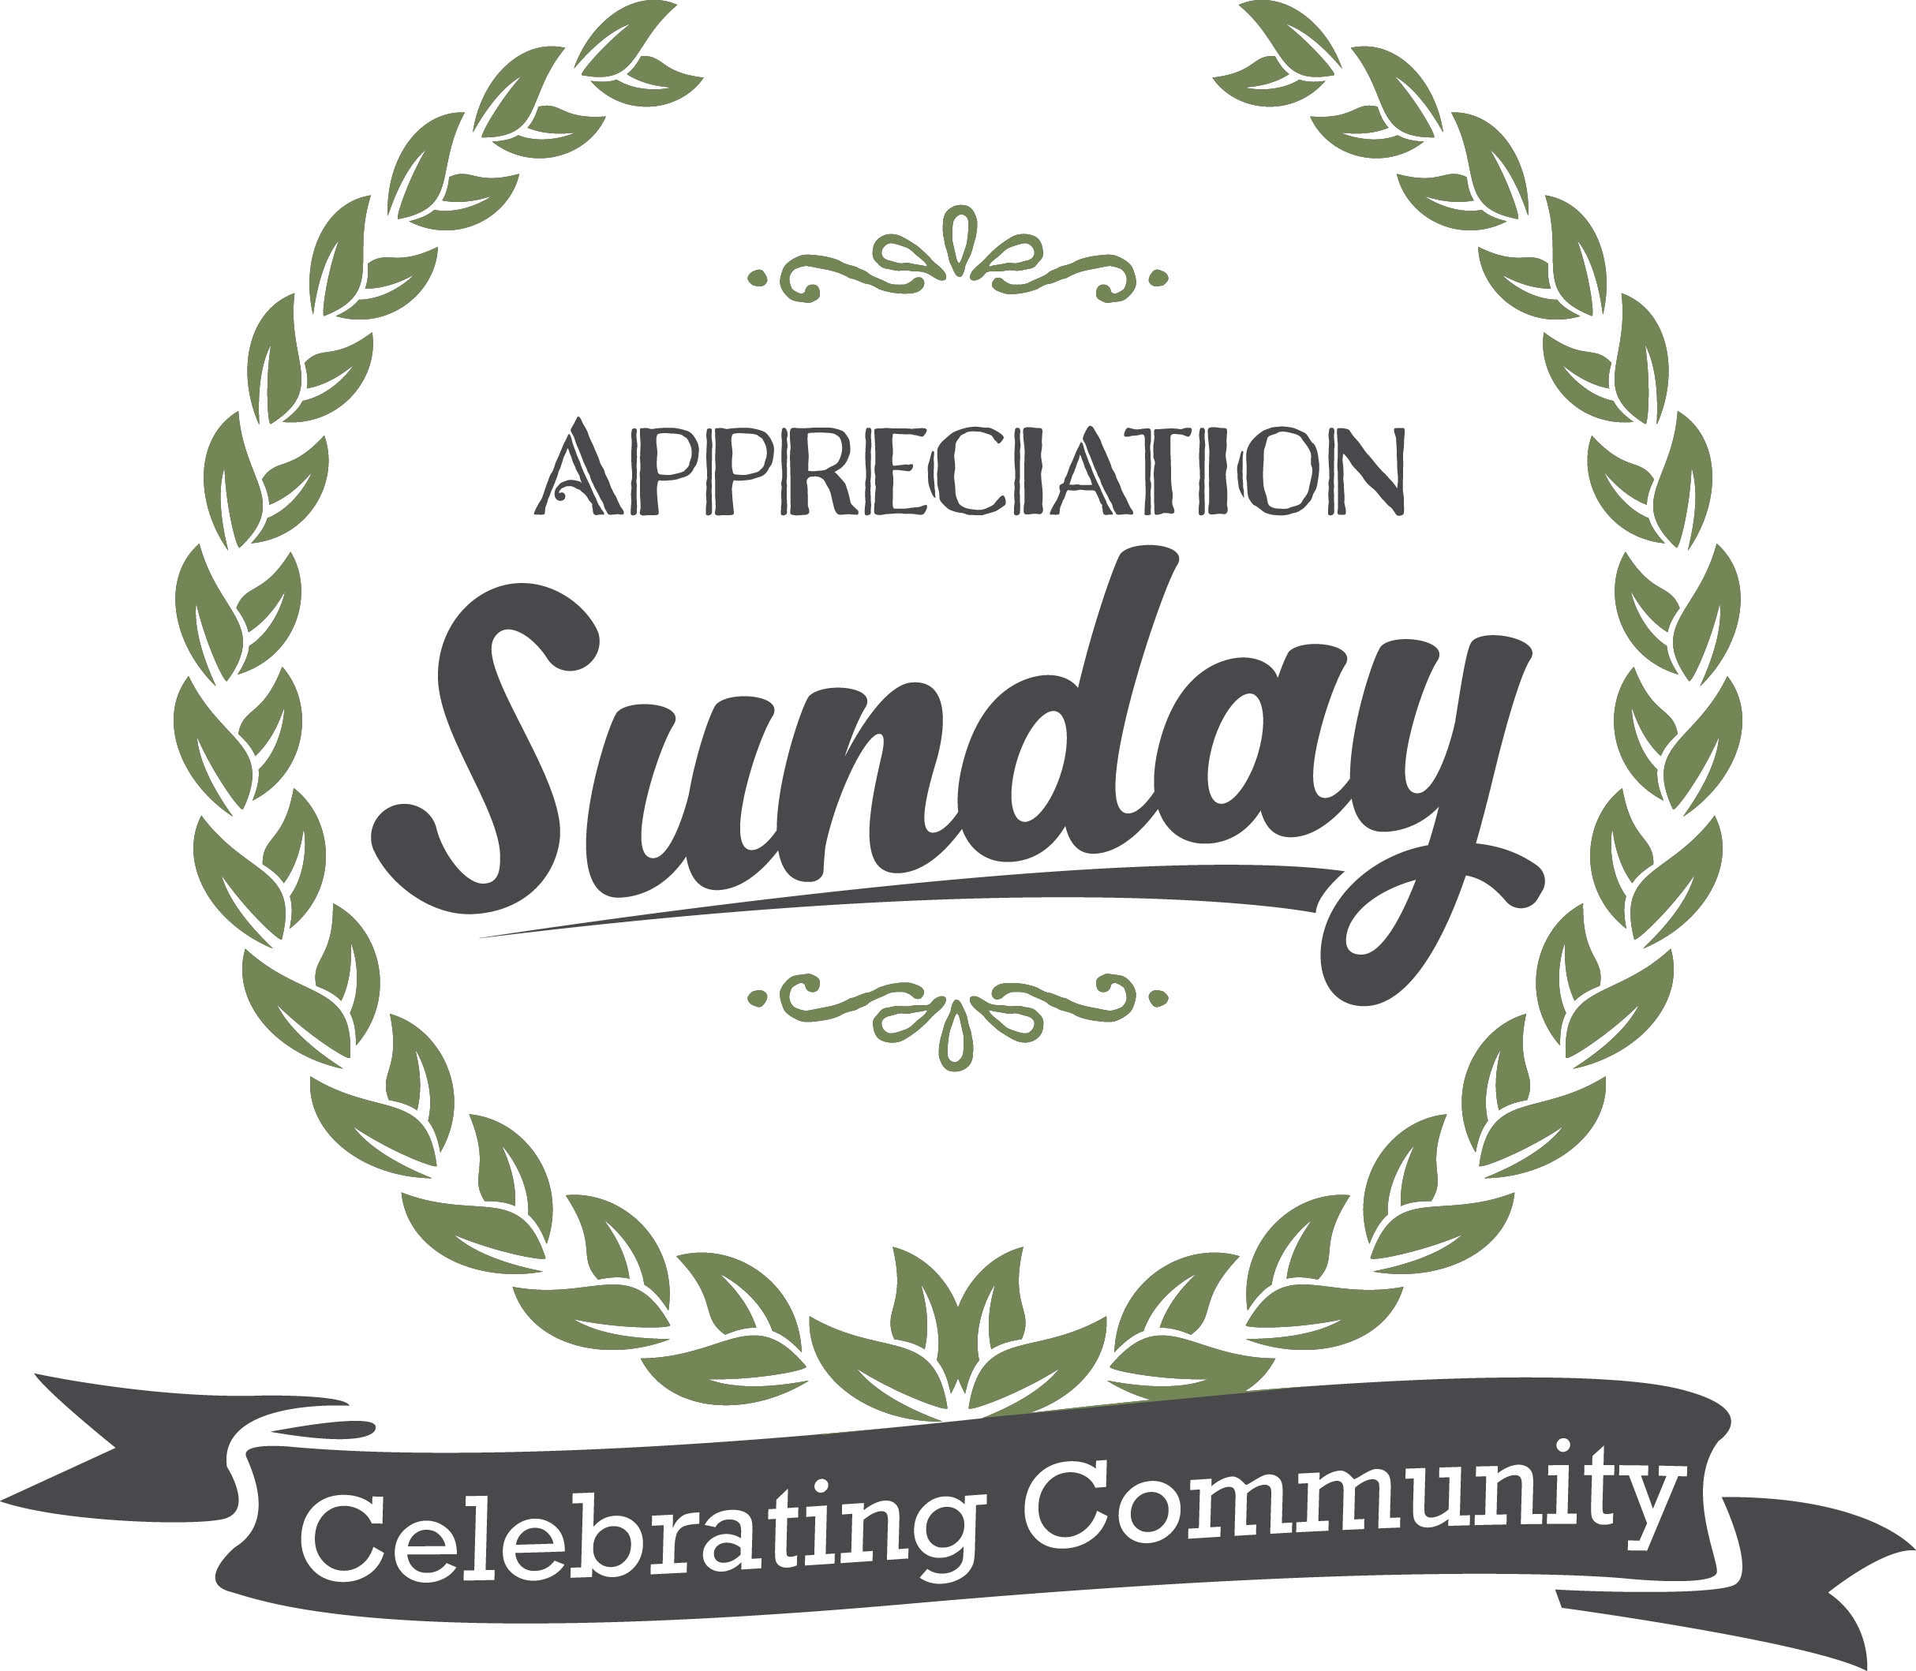
Police Officers Appreciation Day
Sept 11, 2016

Service Schedule
Open With National Anthem/Pledge Allegiance To Flag (5 minutes)
Welcome Scripture Reading Remarks: (3 minutes)
Speech- First Lady or Pastor Assistant – (3 Minutes)
Sample Speech by First Lady
Today we are elated as a church family to honor individuals who have exemplified a spirit of excellence in serving our community with integrity, fairness and impartiality.
We are pleased that our community/municipalities, Governor, Mayor or Chief of Police are present with us today to honor these officers in a manner that is appropriate. This day will truly go down in history for police officers all across our nation.
We ask of you to remain standing as our Pastor comes and asked God’s blessing ...
Pastors Prayer Of Blessing: - (2-3 Minutes)
Song - choir/small group/soloist - (3-5 Minutes)
Remarks – Mayor, or elected office official - (3 minutes each)
Remarks – Governor – (5 minutes)

Recognition by Chief of Police: (5 minutes)
First Lady to call honorees one by one Awards distributed by Governor, Mayor and Chief of Police along with the pastor
Song - Choir sings – (3-5 minutes)
Offering: - (3 minutes)
Sermon – (15-20 minutes) example of sermon - One came back to give thanks - Jesus
Altar Call:
Closing Remarks: (2 minutes) First Lady will say “glad you’re here and lead them to fellowship hall or place for aster church activities. (depending on the fellowship arrangement).
Tips And Suggestions:
- Try to keep service length at 1 hour
- Do not introduce every song and reading by church members just let them walk up and do it
- Only introduce special guests to speak – do it quickly
- Reserve special seating are for the officers and their family
- Give an altar call for anyone who would like prayer for their future, for safety on the job for any personal needs

