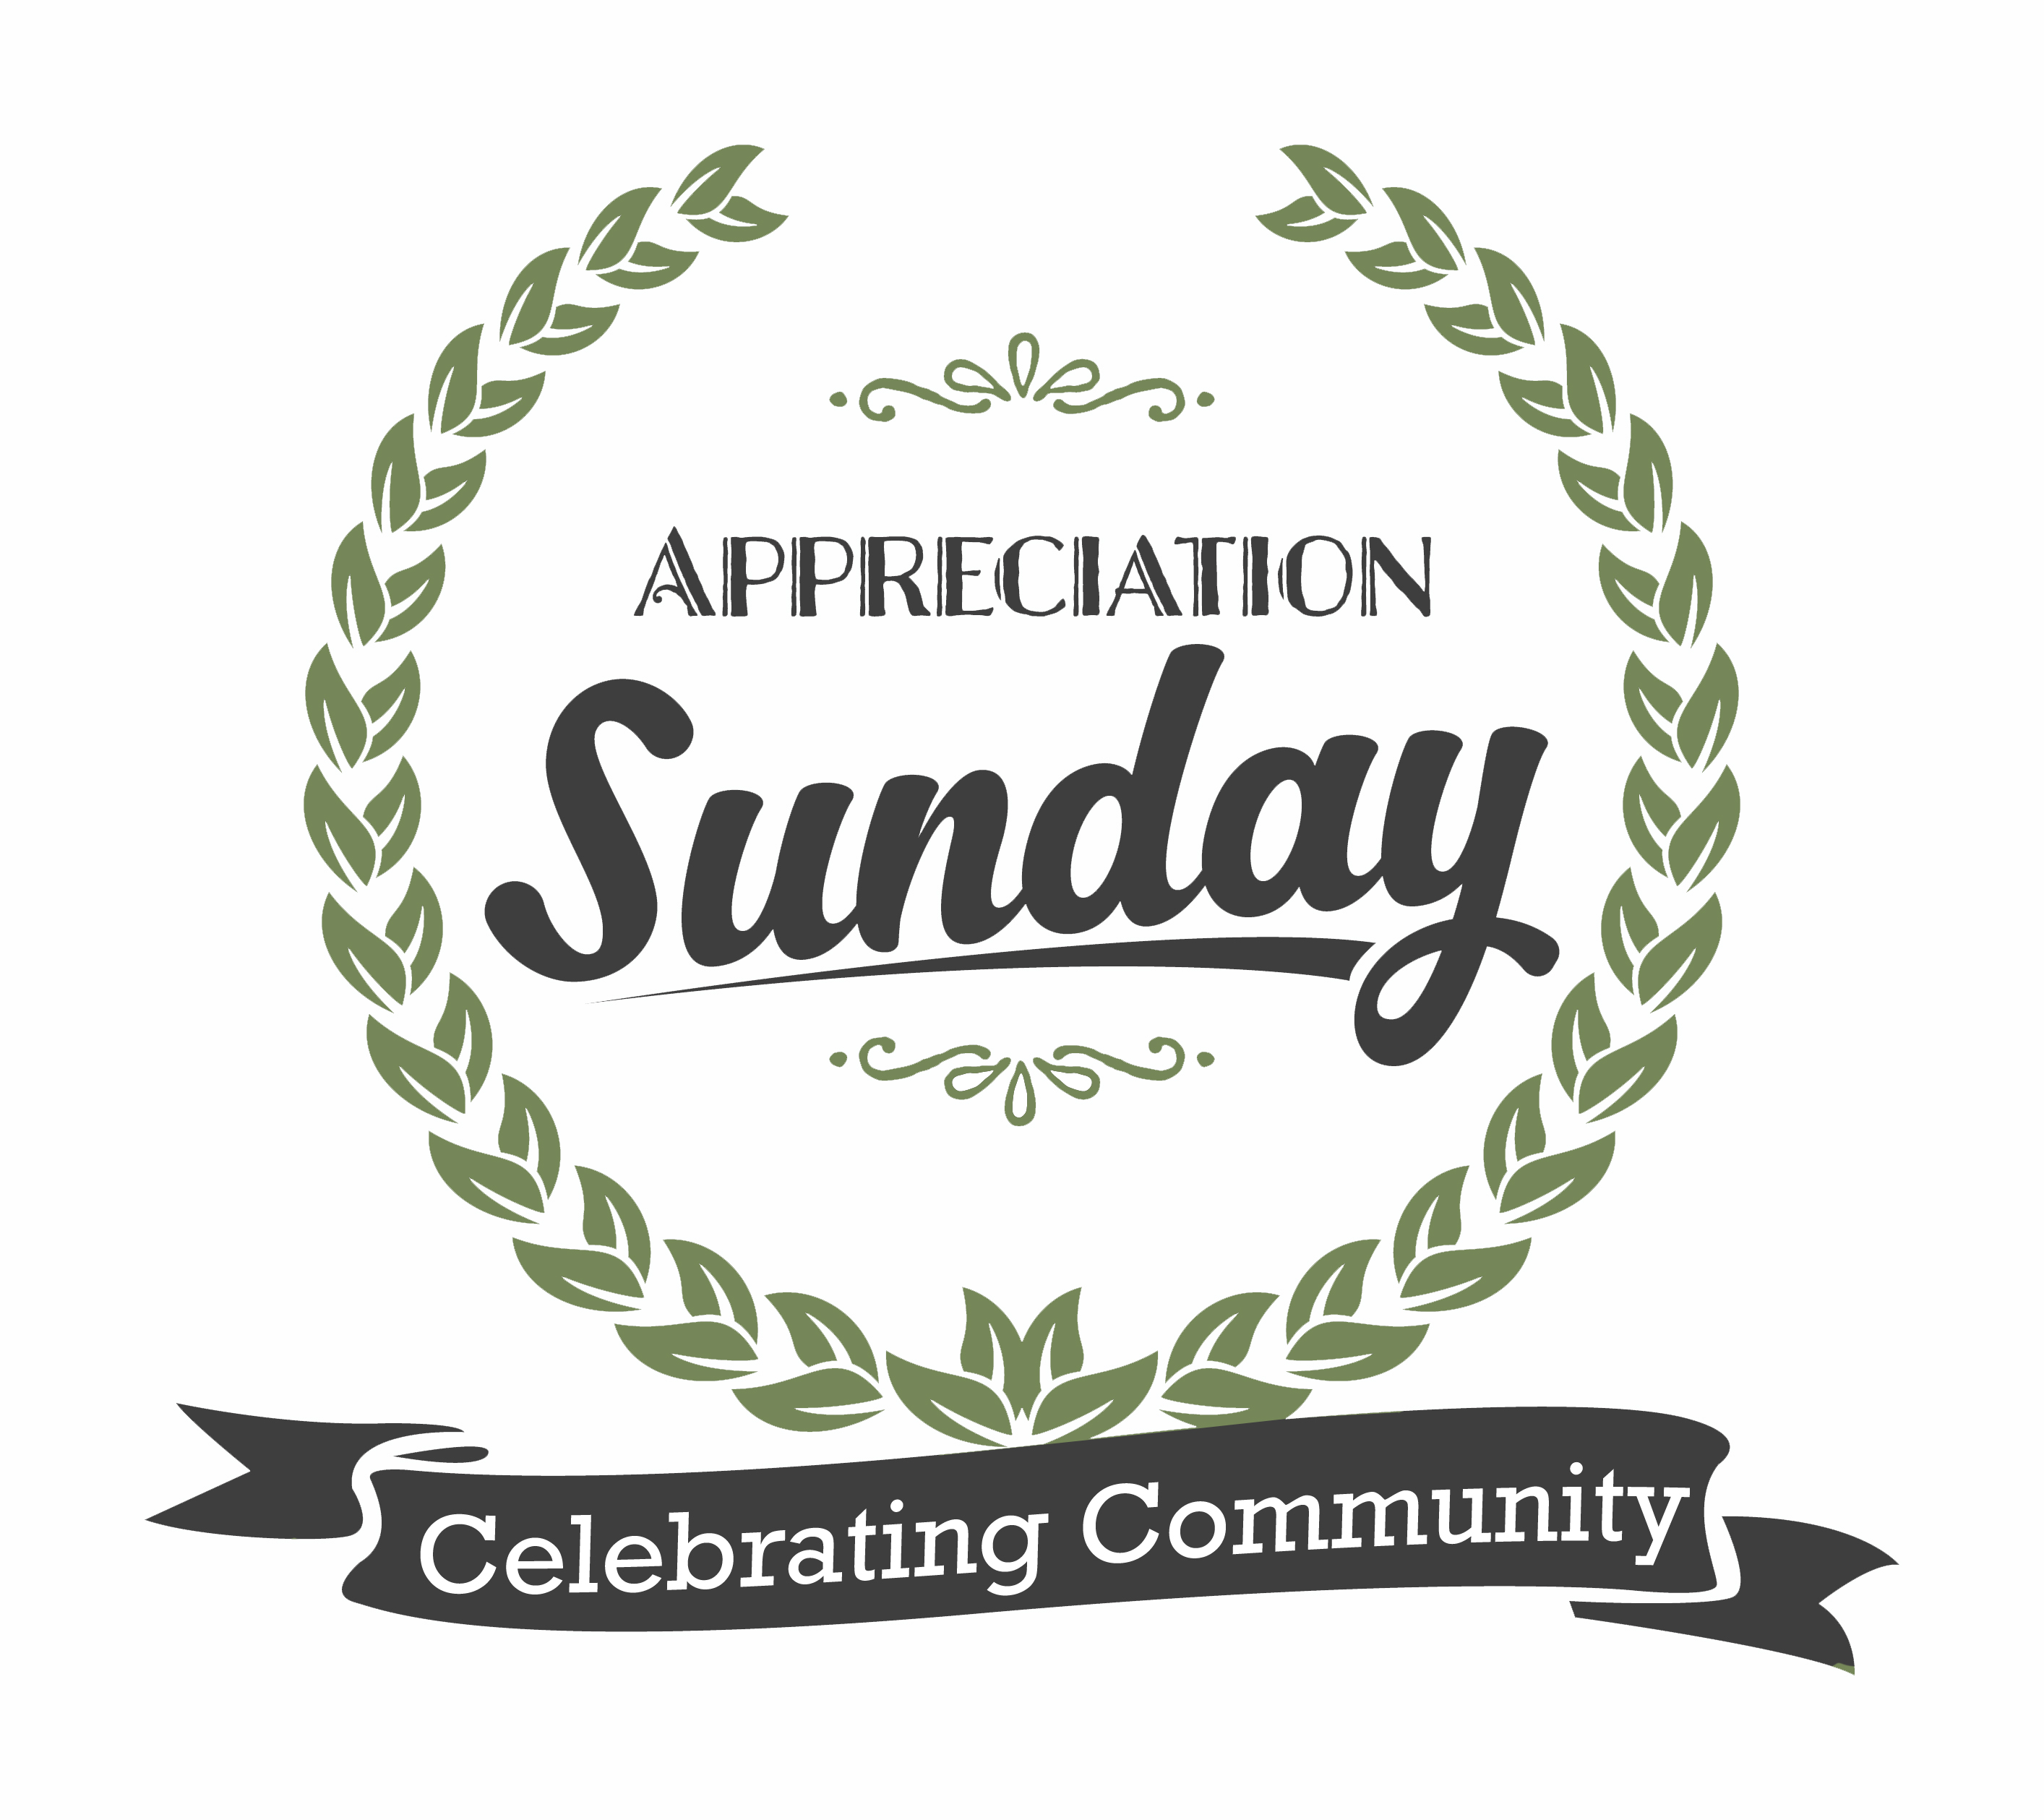

God Is Our Shield!
Text: Psalm 91:1-7 King James Version (KJV)
¹ He that dwelleth in the secret place of the most High shall abide under the shadow of the Almighty. ² I will say of the Lord, He is my refuge and my fortress: my God; in him will I trust. ³ Surely he shall deliver thee from the snare of the fowler, and from the noisome pestilence. ⁴ He shall cover thee with his feathers, and under his wings shalt thou trust: his truth shall be thy shield and buckler. ⁵ Thou shalt not be afraid for the terror by night; nor for the arrow that flieth by day; ⁶ Nor for the pestilence that walketh in darkness; nor for the destruction that wasteth at noonday. ⁷ A thousand shall fall at thy side, and ten thousand at thy right hand; but it shall not come nigh thee.
Intro: I want to welcome all of you to First Responders Day, and I want to especially welcome our law enforcement officers and our fire fighters. I would like for all of our law enforcement officers and fire fighters to stand right now. Let’s give all of these men and women a great round of applause for their selfless sacrifice, and for all they do! Our purpose is to honor you today, and to say “Thank You!” for all you do in serving our community, helping us, and keeping us safe.
Every time you put on your uniform and step out your front door, you put your lives on the line for us. To the families of first responders, we say thank you for sharing your loved ones with us. You have a tremendous stake in this because it’s your loved ones who make a difference in our community. You are important to our community. We want you to know that we appreciate you, as well.
We live in a world that is changing so much. The jobs of our first responders have changed to meet the needs of our society. Our world is dangerous and unpredictable. Uncertainty is the order of the day now. Fear and doubt grip our society, and concern for the future is at a greater level than ever before.
It is within this confusing structure of chaos that we have men and women who will step up to the plate and rise to the occasion, and say, “I accept the responsibility of serving our community. I accept the uncertainty of what each day may hold to protect those in our community who may need my help today. I choose to lay my life on the line for the sake of other lives!” And for that, our saying “Thanks” doesn’t seem to be enough! But we do what we can today to thank you for your selfless and faithful service.
One of the things I so appreciate about our first responders is that they still have the ability to show compassion and concern to those they serve in our community. Our first responders aren’t robots or machines void of feelings, but they are real people who have real families that love them, and they display that compassion and concern for our community! And we are greatly blessed to have men and women of that caliber serving as our first responders!
I. In my time of preparing for today, I began to think about something that both law enforcement officers and fire fighters I have in common, and that is a badge.
- How many of us as children growing up dreamed about being either a police officer or a fire fighter? We would ask our parents to buy us toys pertaining to those things.
- Perhaps one of the first things we did with the toys was to pin our toy badges on and admire ourselves in the mirror. Even as children, we knew the item that identified us as police officers or fire fighters was that badge.
- And once we pinned on those badges, our imaginations were triggered. We became heroes while playing when we caught the bad guys or rescued people from burning buildings.
- Not only did we have a sense of pride for a job well done, we felt some measure of validation that other people needed us, and we were prepared to contribute to those around us when they needed us.
- Perhaps some of our officers and fire fighters played the same games as children, but then they grew up and actually fulfilled those childhood dreams. We honor those who serve us in those capacities. We honor your sacrifice, and we extend our appreciation.
II. I did a little research about badges and learned some interesting things. Let me share some of it with you, given what I learned.
- It is said that the first police badges were, in fact, the coat of arms worn by knights. These coats of arms identified the knight, his allegiance, and his loyal leaders by being displayed on his shield.
    - Much like our law enforcement officers of today who are sworn to protect and serve, medieval knights were sworn in and asked to, “Protect the weak, defenseless, and helpless, and to fight for the general welfare of all.”
- Fire fighters have badges today that reflect the history of fire fighters, and various symbols that represent ranks and positions of fire fighting in history going back to the 1800’s.
- Many times, especially in dress uniform, you will see where first responders wear their badges above the left chest pocket, over the heart for two reasons:
    - To remind them of their pledge to protect.
    - Because the left arm was the arm that often held the coat of arms, the shield, of knights. This protected their hearts, and left their dominant hand free to use a weapon for fighting.
- And so law enforcement officers and fire fighters alike wear a badge, a shield.
III. And when I began to look at all of this, I realized that our law enforcement officers and fire fighters have something in common with God! As first responders, they wear a shield. In our text, David said that God was his shield! Our first responders take care of us in a natural sense, but God takes care of us both naturally and spiritually! And in this day in which we live, I want God to be our shield! And I especially want God to be a shield to our first responders! Let me tell you what it means when God is your shield.
- First, it means that God is acting as the authority on your behalf.
    - Law enforcement officers and fire fighters operate under authority that has been granted to them by local and state government. They have been empowered to enforce the laws that are meant to keep us safe and provide a structure through which our society can operate.
    - In fact, the Bible tells us that our first responders have gotten their authority from God: “Let every soul be subject unto the higher powers. For there is no power but of God: the powers that be are ordained of God.” Rom. 13:1
    - So it should come as no surprise that Jesus would stand up one day and say, “All power is given unto me in heaven and in earth.” What does that mean for Christians? Simply this; if you belong to Him, He is responsible for you, and He will take care of you!
    - The Bible tells us that we wrestle not against flesh and blood, but against principalities, against powers, against the rulers of the darkness of this world, against spiritual wickedness in high places.
    - Our first responders deal with flesh and blood situations simply because there is a spiritual battle going on in our world today.
- God is our authority against the spiritual warfare that rages against us! And all of us are in a spiritual war in which the enemy of our souls would love to destroy us! The enemy came to steal, kill, and destroy, but Jesus came that we might have life, and have it more abundantly!
    - Aren’t you thankful that you have God as the acting authority in your life?
- And secondly, since God is our shield, He is our protection.
    - Our first responders work hard to keep us safe.
    - They serve, they protect.
    - Because God is my authority, because His name is on the shield that protects me, I am safe! “The name of the LORD is a strong tower: the righteous runneth into it, and is safe.”
    - David goes on to say, “For he shall give his angels charge over thee, to keep thee in all thy ways.” God keeps and protects us!
    - I know that none of us will live forever, but I’ve seen times when God has protected my family from what could have been disaster! I don’t know what would have happened if God had not been our shield!
    - No wonder Paul was able to write, “We are troubled on every side, yet not distressed; we are perplexed, but not in despair; Persecuted, but not forsaken; cast down, but not destroyed;”
    - Why could he pen those words? Because when God is your shield, you have the great confidence that He will protect you and take care of you!
- I come to this pulpit today to tell you that our God is our shield, and we can have great confidence in His authority and in His ability to protect us!
    - How can we be sure that He is our shield? By putting our trust in Him. It’s not enough to acknowledge that there is a God. The devil himself knows that God exists. David wrote about it; “But let all those that put their trust in thee rejoice: let them ever shout for joy, because thou defendest them: let them also that love thy name be joyful in thee. For thou, LORD, wilt bless the righteous; with favour wilt thou compass him as with a shield.” The prophet Isaiah was so confident in God as a protector that he said now weapon formed against us would prosper.
    - These first responders with us today took an oath to protect our community to the best of their ability. They have been entrusted with keeping the peace and ensuring our safety. We trust them with those responsibilities.
    - I want you to know today that you can trust God. What does it mean to trust Him? It means to confide in Him, to have hope in Him, and thereby find your place of safety and refuge.
  - As a society, we have empowered our first responders, and we trust them to serve and protect us. But who do our first responders trust in to look after them? To all of our first responders let me say that you can trust God to look after you. We as caring citizens will have your back to the best of our ability, but you can look unto Jesus for His help. He loves you. He cares for you, and He cares for your families.
Conclusion: As we conclude this service, our church wants to give a little something to every first responder with us today. Let me explain what it is. In the book of Acts, we are told that God wrought great miracles through Paul, to the point that handkerchiefs and aprons were brought from him to those who were sick. The diseases departed from the sick and even evil spirits went out of them.
Today, we want to give prayer cloths to our first responders. Please know that there is nothing special about these cloths in a physical sense. These cloths are not magical. But they have been prayed over before you came today, and we will pray over them again this morning.
While your badges represent your authority and commitment to serve, may these prayer cloths be simple reminders that you have been prayed over. Let them remind you that we have asked God to go with you and to protect you when you are on duty. You can keep them in your service vehicles, in your wallets or purses, or wherever you would like to. We just want you to have that constant reminder that you have been prayed over, and that you are appreciated for your sacrifices.
I’d like to ask our first responders to come to the front and face the congregation.

